**Pre Implementation Plan:-**

**===================================================================================**

Login to APIC GUI: https://10.200.4.15 Riyadh APIC

1. The health of controller should be fully fit: Go to System 🡪 controllers (take snapshot as below)

1. Go to System 🡪Faults (screenshot) & Go to System 🡪Dashboard (Take snapshot as below)

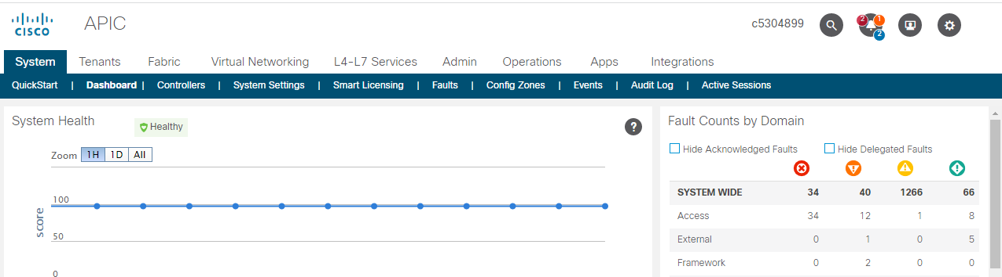

1. Take backups of the APIC fabric. (Riyadh- **https://10.200.4.15**)

Navigate to Admin -> Config Rollbacks 🡪 Select tenants as “All fabric”

Put CHG# in the Description Field >> Click on "Create A snapshot Now"

**Implementation Plan:-**

**=====================================================================================**

1. Login to Riyadh APIC : [https://10.200.4.15](https://10.200.4.15/)
   1. Go to Tenants -> 01_GMP -> Networking -> L3Outs -> GMP1a_PAYROLLout -> External EPGs -> Payroll_in
   2. Go to Subnets -> Add ‘+’
      1. IP Address : 154.84.155.110/32
      2. Name : GMP1a_PAYROLLout
2. Go to Tenants -> 01_GMP -> Networking -> L3Outs -> GMP1a_PAYROLLout -> Logical Node Profiles -> GMP1a_PAYROLLout -> Configured Nodes -> topology/pod-1/node-2101 -> Static Routes -> Click on “+”
   1. Prefix : 154.84.155.110/32
   2. Next Hop Addresses : 192.168.4.30 , Preference : 1

Submit

1. Go to Tenants -> 01_GMP -> Networking -> L3Outs -> GMP1a_PAYROLLout -> Logical Node Profiles -> GMP1a_PAYROLLout -> Configured Nodes -> topology/pod-1/node-2102

-> Static Routes -> Click on “+”

* 1. Prefix : 154.84.155.110/32
  2. Next Hop Addresses : 192.168.4.30 , Preference : 1

Submit

**Validation Steps :-**

*******Login to APIC - ap-sa-1a-aci-7101.net.sap.corp*******

a. Login to APIC GUI https://ap-sa-1a-aci-7101.net.sap.corp and check the APIC cluster health: SYSTEM -> Controllers -> Cluster Health --- take screenshot

b. Login to APIC GUI https://ap-sa-1a-aci-7101.net.sap.corp and check the APIC cluster health: SYSTEM -> Dashboard -> Faults counts by domain --- take screenshot

**Login to APIC CLI**

ssh apic#Netsec_TACACS\\C5263144@ap-sa-1a-aci-7101.net.sap.corp

Run the following commands:

show controller

show running-config tenant 01_GMP external-l3 epg Payroll_in l3out GMP1a_PAYROLLout | grep 154.84.155.110/32

show external-l3 static-route tenant 01_GMP | grep 154.84.155.110/32

**Rollback:-**

**--------------**

Rollback the configuration from config snap taken in precheck.

*******Login to APIC - ap-sa-1a-aci-7101.net.sap.corp*******

1. Rollback to the config snapshot taken during Pre-Implementation Steps:

Login to APIC UI > Admin > Config Rollbacks > Config Rollback for: ‘Select for All Fabric’ from Dropdown > Select the Snapshot taken during Pre-Implementation Steps > Click ‘Rollback to this configuration’ button